SQL Assignnment 1

Creating sample tables and inserting values.
Create the following tables with the given structures and insert sample data as specified

A) SALESPEOPLE
snum int(4)
sname varchar(10)
city varchar(10)
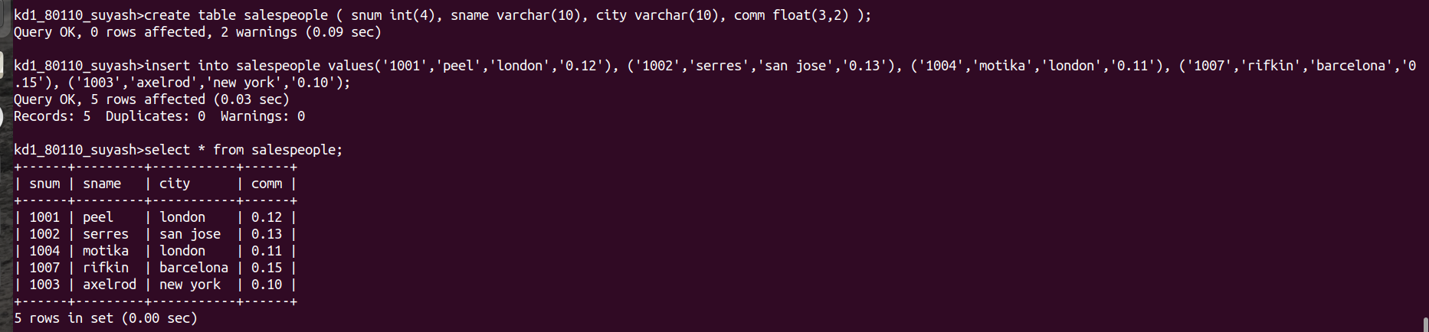
comm float(3,2)

B) CUSTOMERS
Cnum int(4),
Cname varchar(10)
City varchar(10)
Rating int(4)
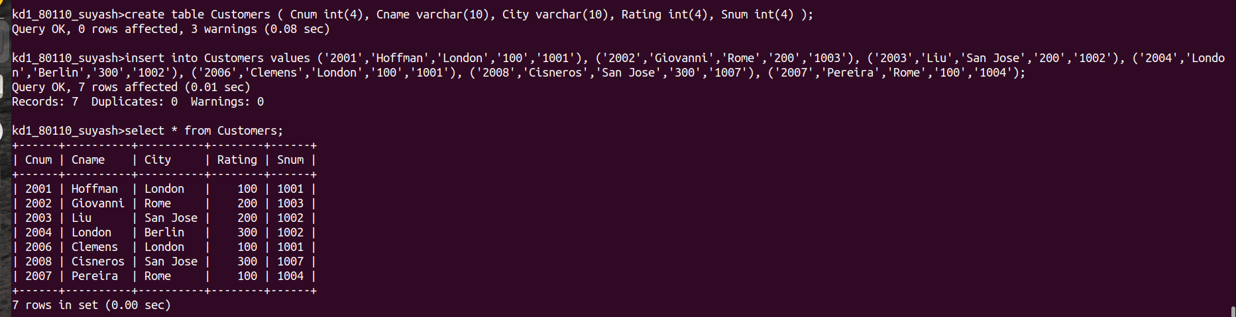
Snum int(4)

C) ORDERS
Onum int(4),
Amt float(7,2),
Odate date,
Cnum int(4),
Snum int(4)
